

**Doordash Setup Manual**

A Simple Step-By-Step Guide

**Table of Contents**

Introduction to the Doordash Drive 3

Subscribe to the Doordash Drive module 3

Enable Online for Delivery Orders 5

Guest places an order online 6

Tracking the Dasher status on the POS 8

How Customers can track their orders? 10

# **Introduction to the Doordash Drive**

Now the online orders will be delivered to the guest’s doorstep at lightning-fast speed. With this integration, Doordash can assign a dasher to the orders placed on the eCommerce Express platform, pick up the orders from the restaurant and deliver them to the guests. Guests can track their orders from the online portal account and servers can also track the driver’s location, know the pickup time, and get the driver’s status directly from the POS. This means a seamless order delivery with Quantic-Doordash integration.

# **Subscribe to the Doordash Drive module**

## doordash-drive-third-party-app-download

1. Log in to the location’s backend portal.
2. Click the **Hamburger** icon on the top left corner.
3. Click **App Store** to open the associated third-party modules.
4. Locate the **Doordash Drive** module as shown in the screenshot.
5. Click the **Download** icon next to the Doordash Drive module.

## doordash-drive-popup

1. Click **Subscribe** on the Doordash Drive popup and then click the **Settings** icon next to the Doordash Drive.

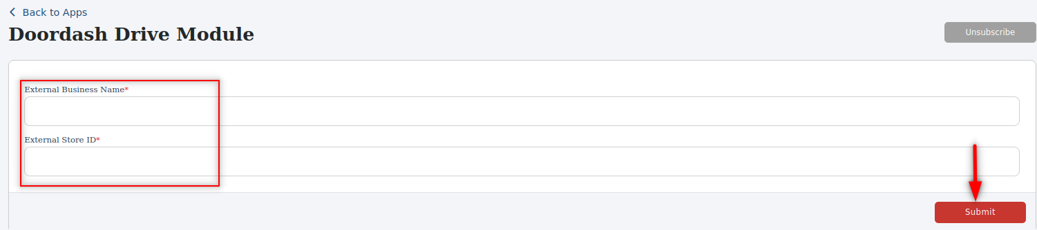

1. Now enter the **External Business Name** and **External Store ID** that you may have received from the onboarding team.
2. Click **Submit** to save the settings.

# **Enable Online for Delivery Orders**

The start accepting the delivery orders from the online channels, you will need to enable the Online for the Delivery service area type. You can do it from the backend portal as shown in the steps below.

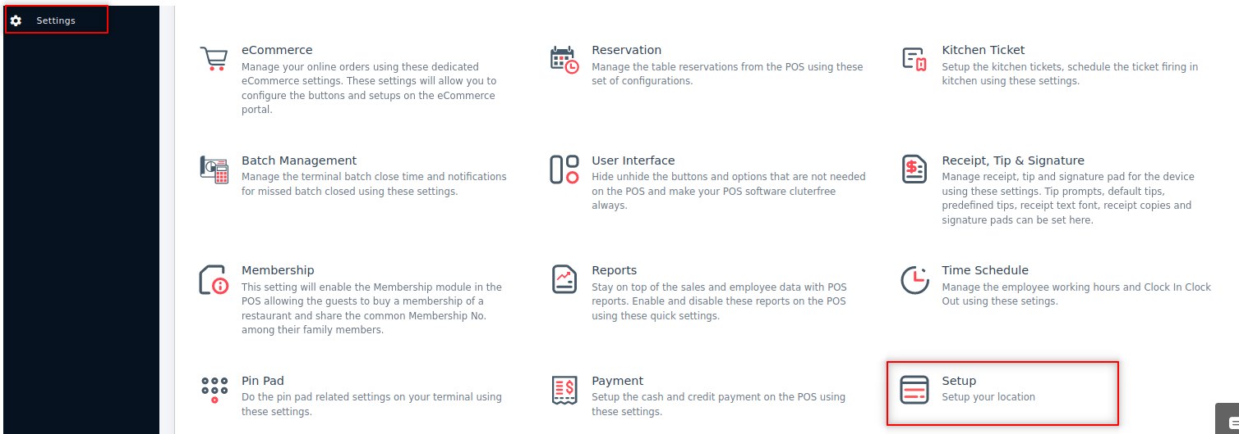

1. Go to the left navigation menu and tap **Settings**.
2. Click **Setup** as shown in the screenshot.

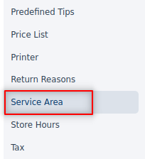

1. Click **Service Area**.

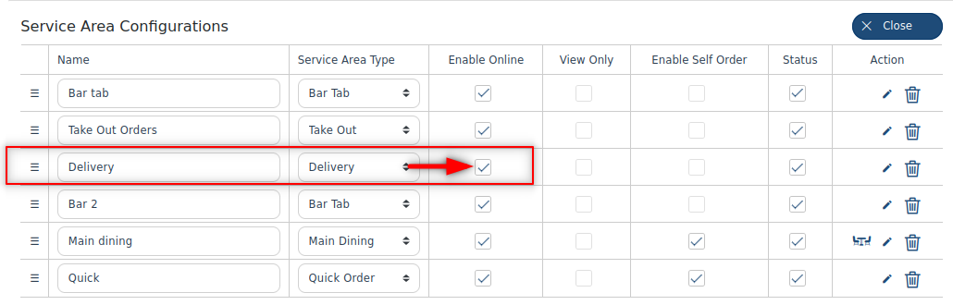

1. On the **Service Area Configurations** screen, click  and tap the **Enable Online** checkbox adjacent to the **Delivery** service area type.
2. The **Changed Successfully** message will pop up indicating the settings are saved successfully.
3. Click the  icon next to the Delivery Service area.

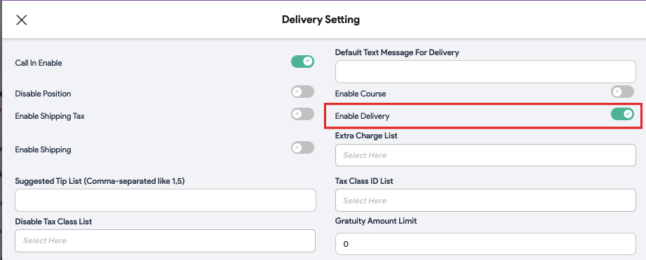

1. Turn on the **Enable Delivery** button as shown in the screenshot.

# **Guest places an order online**

When guests visit the online website, the Delivery option displays on their screen as shown in the screenshot. Guests need to tap the Delivery option, enter their address, pay for the order, and wait for the food to get delivered. Let’s understand this with an illustration.

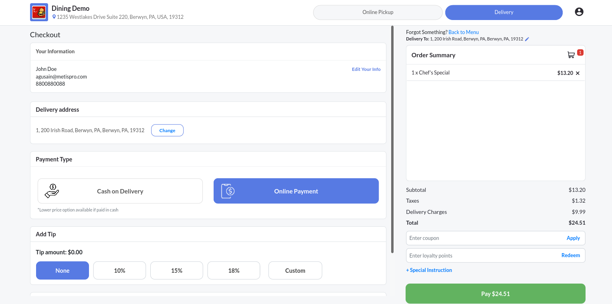

1. John visited the eCommerce Express website and chose the **Delivery** option to get the food delivered to his location.
2. He selected the food, proceeded to the checkout page, added the delivery location, and paid for the order.

|  | 1. The order number is generated, and the same order number will appear in the POS under the **Delivery Order** section. In this example, the order number is 0167. 2. The order receipt displays all the details such as a delivery address, customer phone number, delivery ID, order subtotal, and delivery charges levied on the order. |
| --- | --- |

# **Tracking the Dasher status on the POS**

The Delivery order placed via eCommerce Express can be seen on the Quantic POS in the Delivery Order section. Quantic has collaborated with DoorDash for all third-party deliveries. In the following section, you will see how a server can see the dasher status on the POS.

|  | 1. Open the left navigation on the POS and click **Delivery Order** to check the order details. |
| --- | --- |

|  | 1. Select the **Third Party Delivery** tab. 2. The list of all third-party deliveries will appear, as shown in the screenshot. Tap on any order to view the status of the delivery driver. We need to check the status of order #0167, so we tapped on **Details** next to it. |
| --- | --- |

|  | 1. Let's take a look at order number 0167. 2. It shows the complete order details like customer name, delivery address, delivery date/time. 3. As the order is waiting for the driver to be assigned for delivery,  status shows in front of **Dasher Detail.** 4. Click the  button to see if the Dasher Detail status has changed or not. |
| --- | --- |

|  | 1. Once DoorDash assigns the dasher, it shows  adjacent to the **Dasher Details**. The dasher’s name and contact number are also displayed underneath the Dasher Details. 2. You can also track the real-time location of the dasher by clicking on the  button. |
| --- | --- |

|  | 1. This is how the dasher location will show on your screen. |
| --- | --- |

# **How Customers can track their orders?**

Customers can track their orders directly from the profile section in the online portal. They can see if the driver has been assigned to the order, estimated pick up and drop time of the order including the dasher’s phone number. Here are the steps that customers can follow to track orders.

|  | 1. Visit the **eCommerce Express** website. 2. log in to the portal with username/email and password. 3. Click  and tap **See your profile**. |
| --- | --- |

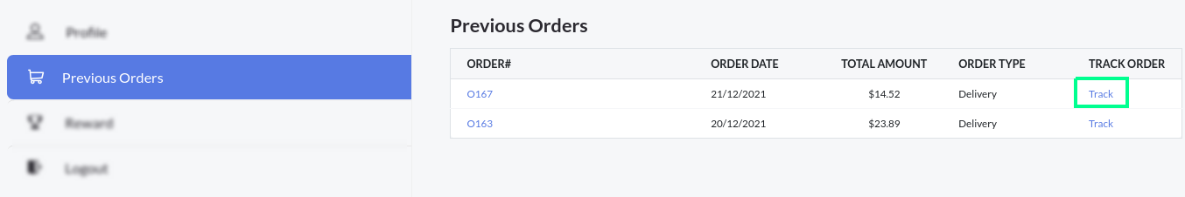

1. Go to the **Previous Orders** section.
2. The list of all previous orders will be displayed on the screen.
3. Look for the order number you want to track and click **Track** in front of it.

|  | 1. The **Order Track Status** pop-up will inform you about the order status, Dasher name, estimated pickup, and delivery. 2. See the **Live Track** section at the bottom and tap on **Click Here** link. |
| --- | --- |

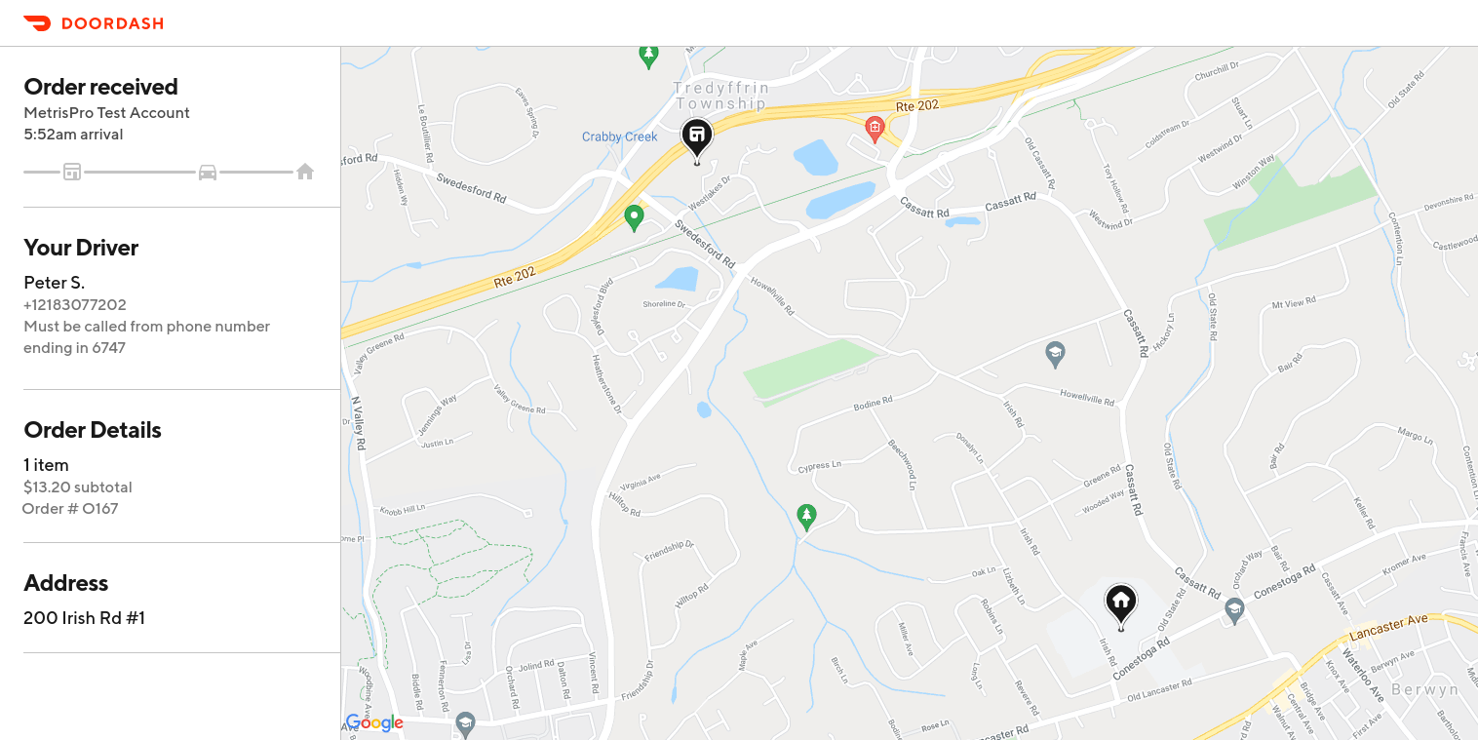

1. Here is a live tracker that shows the real-time location of the dasher. It also includes Order Status, Order Details, and Customer Address.
2. You can zoom in to the screen to get the precise location of the dasher.



**Thank you for**

**Choosing Quantic**

We’re a digital toolbox. We help you grow

and manage your business.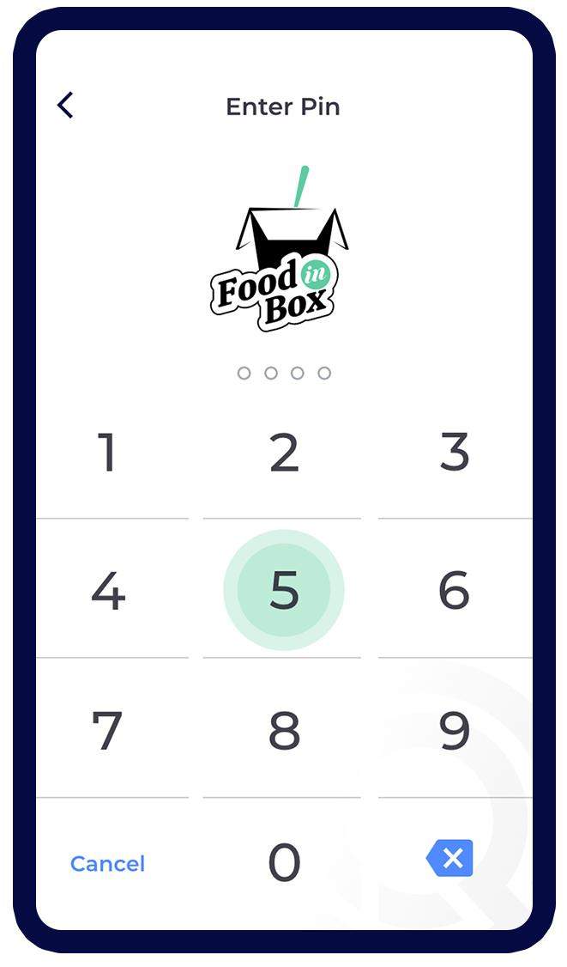

*getquantic.com*

Free learning platform for   
Quantic Products.

*university.metispro.com*